**FPT ACADEMY INTERNATIONAL**



## FPT – APTECH COMPUTER EDUCATION

WILSON SPORTING GOODS

|  |  |  |  |
| --- | --- | --- | --- |
| **Center Name** | | FPT – Aptech – HCM2  Address: 590 Cach Mang Thang Tam, District 3, Ho Chi Minh City | |
| **Instructor** |  | Ms. Le Mong Thuy |  |
| **Class** |  | T1.2010.E0 |  |
| **Group** |  | 7 |  |
| **Group members** | | **Name** | **Student ID** |
|  |  | Dương Đình Phúc | Student1280927 |
|  |  | Lý Vĩnh Phú | Student1280935 |
|  |  | Trần Văn Tính | Student1281649 |
| **Duration** | Start date | 25th December 2020 |  |
| End date | 26th January 2020 |  |

**This is to certify that**

**Mr.:**

Dương Đình Phúc

Lý Vĩnh Phú

Trần Văn Tính

**has successfully designed & developed**

eProject: Wilson Sporting Goods website

**Submitted by:**

Trần Văn Tính

**Date of issue:**

**Authorized Signature:**

# ACKNOWLEGMENT

On behalf of all the members of group 7, I would like to thank you all for the hard works, supports to make this eProject complete successfully. Especially, Ms. Le Mong Thuy, our teacher, she helped us a lot from the day that we started to study at FPT Aptech. With this eProject, she has guided us with her enthusiasm and rigorous, because of her guiding, we would be able to finish this project. Besides, I want to thank all the team member of group 7, each of the team member has been working continuously in 4 weeks in order to complete this project. The last but not least, we would like to say thank you to our family for always supporting us, creating the best conditions for us to focus on the project, and putting faith in the dreams we pursue.

# SYNOSIS

We need to create a website that meet all the requirement of our customer, WILSON SPORTING GOODS is selling various types of Sports Goods. The company advertises by distributing the pamphlets, advertising on television and so on. Due to rapid development in internet field, the company decides to launch a website where people will get all the information about the various products available with them easily.

# PROBLEM DEFINITION

The Wilson Sporting Goods Company is an American sports equipment manufacturer based in Chicago, Illinois. From 1989, it has been a subsidiary of the Finnish group Amer Sports, since 2019 itself a subsidiary of the Chinese group ANTA Sports.[3] Wilson makes equipment for many sports, among them baseball, badminton, American football, basketball, fastpitch softball, golf, racquetball, soccer, squash, tennis, pickleball and volleyball.

The company owns the brands Atec, DeMarini, EvoShield, Louisville Slugger, and Luxilon to provide sports equipment and protective gear for baseball, lacrosse, softball, and tennis.

Looking at the growing competition, they have decided to find an easy source to reach to the customer and the solution they thought of is of building a web site which will host all the information about their shop.

# 

# CUSTOMER'S REQUIREMENTS SPECIFICATIONS (CRS)

**Client: WILSON SPORTING GOODS**

### Business/Project Objective:

WILSON SPORTING GOODS is selling various types of Sports Goods. The company advertises by distributing the pamphlets, advertising on television and so on. Due to rapid development in internet field, the company decides to launch a website where people will get all the information about the various products available with them easily.

We are supposed to create a website for them with the below mentioned requirement specifications.

The website is to be developed for the Windows Platform using HTML5, JavaScript, Bootstrap, jQuery and Geolocation. The site should work well in all leading browsers including Chrome, IE, Firefox etc.

**Input to the system:**

* Searching products depend on price, brand and information about the WILSON GOODS.
* Feedback about the quality of products.

**Output from the system:**

* A menu that will categorize all the functions of the site.
* Display the list of available albums category wise.
* Categories can be baseball, basketball as well as other products company, all should be displayed separately.
* Display the various offers by the shop.
* Display the details of the products
* Display the price list of the various items available in the shop i.e.
* Site should be able to provide brief introduction/history about the shop under About Us page.
* The location of the shop under Contact-Us page.
* Besides the above requirements, the site should have look and feel as per the industry standards.

**Process**:

* + - * Compare Products

**Expected delivery date:** 22-JAN-2021.

**List of deliverables:**

* + - * Document Word.
      * User Guide.
      * Source code.

### Hardware/ Software Requirements:

* **For developer**

**Hardware**

* + Intel Pentium 4 processor or higher
  + 1 Gigabytes of RAM or higher

**Software**

* + Windows 7 OS or higher
  + Adobe Dreamweaver
  + Web browsers such as IE, Chrome or Firefox are supporting HTML5, CSS3 and Javascript.
* **For web users**

**Hardware**

* + Intel Pentium 4 processor or higher
  + 512 Megabytes of RAM or higher

**Software**

* + Windows XP OS or higher
  + Web browsers such as IE, Chrome or Firefox are supporting HTML5, CSS3 and Javascript.

# SCOPE OF THE WORK (IN BRIEF)

After a long and detailed discussion, our group has decided to create a website contain the following webpages:

1. ***Homepage***: Display information about newest-selling products, an introduction about Wilson Sporting Goods.
2. ***Shop***: Display all available album based on category
3. ***Other products***: Display other product beside Wilson (Adidas, Nike,..)
4. ***About Us***: Display the information of the company, clients’ review and about us.
5. ***Contact***: Display the address of the company, allow customers to request any information they want to Wilson Sporting Goods.
6. ***Compare***: review and compare other products

# Architecture and design of the system

Webpage request



Requested Page

**RENDERING**

**ENGINE**

**CSS CODE**

**HTML CODE**

**WEB SERVER**

**WEB BROWSER**

**CLIENT**

**SERVER**

# Diagram of the website

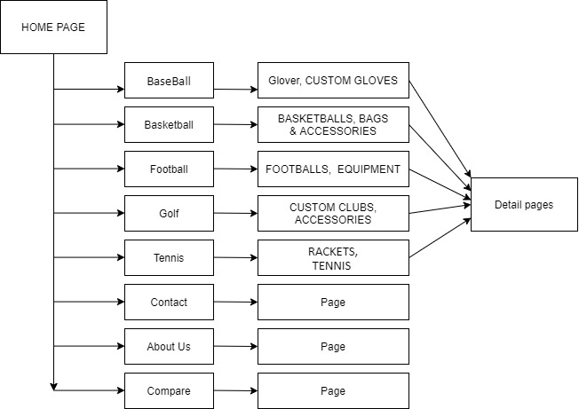



# TASK SHEET REVIEW 1

|  |  |  |  |  |  |  |  |
| --- | --- | --- | --- | --- | --- | --- | --- |
| **Project Ref. No.:**  **eP/Advertisement Portal Management**  **System/01** | | **Project Title:** | **Activity Plan Prepared By:** | **Date of Preparation of Activity Plan:** | | | |
| **Sr.**  **No.** | **Task** | **Actual**  **Start Date** | **Actual Days** | **Team**  **Mate Names** | **Status** |
| 1 | Problem Statement | WILSON SPORTING GOODS | Tinh | 28-DEC-20 | 1 | Tinh | Completed |
| 2 | Analysis of Rhythm House requirements about the website | 28-DEC-20 | 1 | Tinh | Completed |
| 3 | The scope of the work (in brief) | 28-DEC-20 | 1 | Phu | Completed |
| 4 | Architecture and design of the system | 28-DEC-20 | 1 | Phuc | Completed |
| 5 | Diagram of the website | 28-DEC-20 | 1 | Phu | Completed |
| 6 | Task Sheet | 28-DEC-20 | 1 | Phuc | Completed |

|  |  |
| --- | --- |
| **Date:** | |
| Signature of Instructor:  **Ms. Le Mong Thuy** | Signature of Team Leader:    **Tran Van Tinh** |

# SITE MAP



# MOCK OF THE WEBSITE

1. **Homepage**

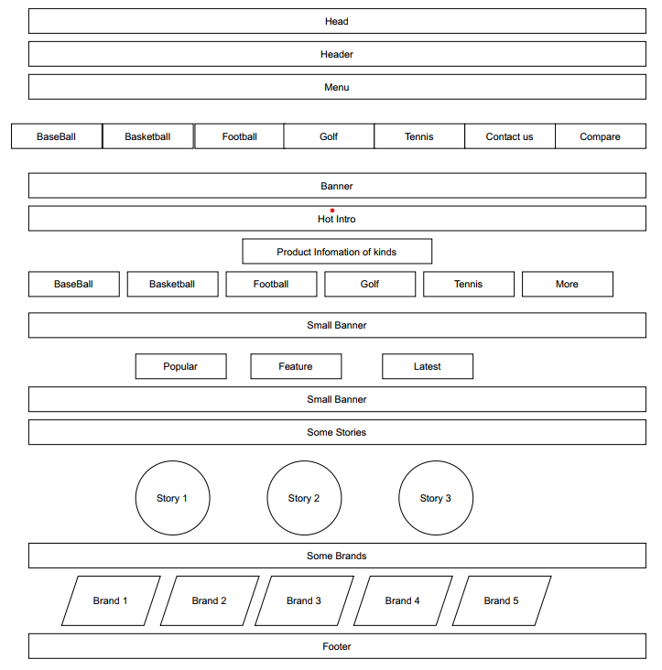

1. **Shop**

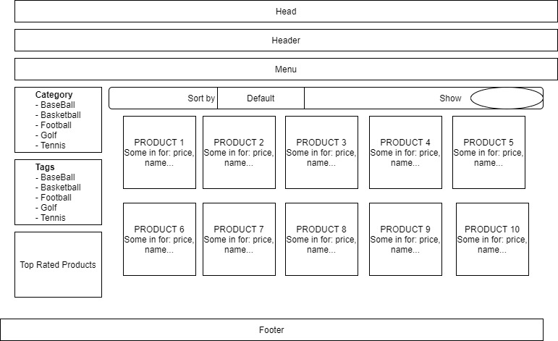

1. **Other Products**

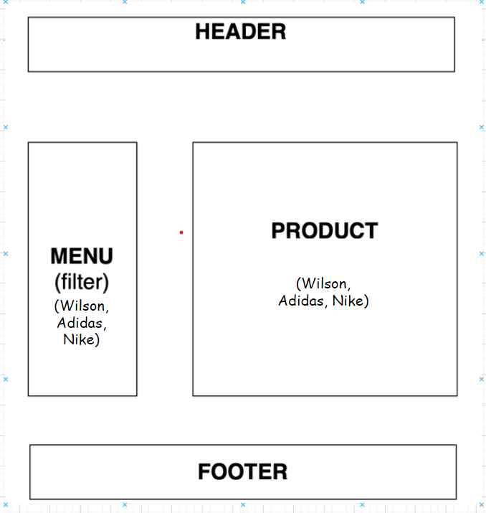

1. **About us**

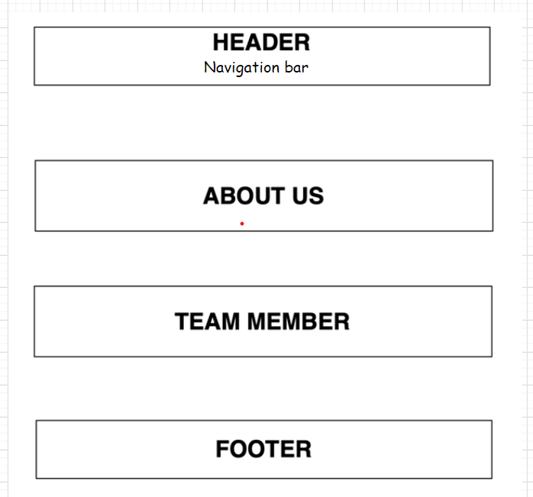

1. **Contact us**

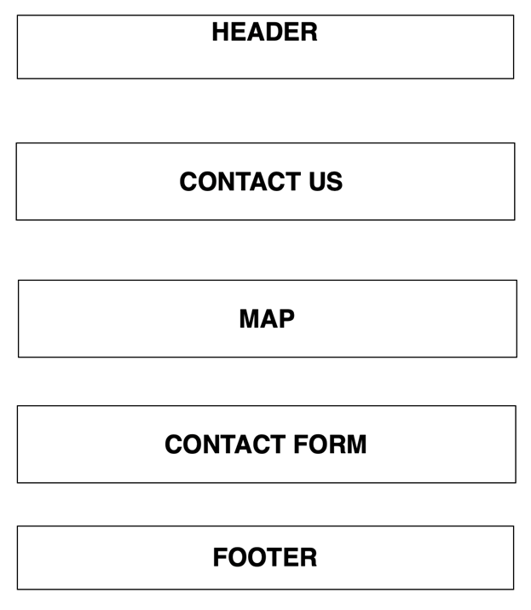

**6.Compare**

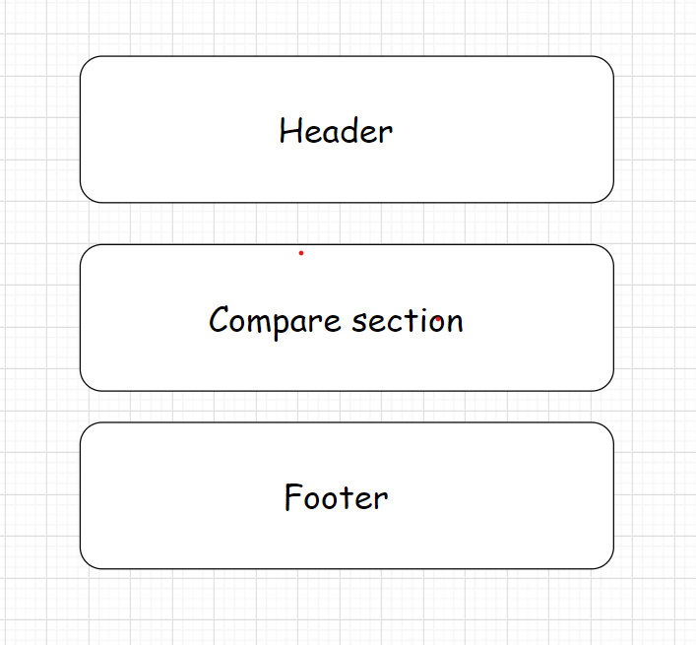

# TASK SHEET REVIEW 2

|  |  |  |  |  |  |  |  |
| --- | --- | --- | --- | --- | --- | --- | --- |
| **Project Ref. No.:**  **eP/Advertisement**  **Portal Management System/01** | | **Project Title:** | **Activity Plan Prepared By:** | **Date of Preparation of Activity Plan:** | | | |
| **Sr.**  **No.** | **Task** | **Actual Start Date** | **Actual Days** | **Team Mate Names** | **Status** |
| 1 | Site map | Wilson Sporting Goods | Khoa | 30-Dec-20 | 1 | Tinh | Completed |
| 2 | Mock of the website | 30-Dec-20 | 2 | Phu | Completed |
| 3 | Task sheet | 30-Dec-20 | 2 | Phuc | Completed |

|  |  |
| --- | --- |
| **Date:** | |
| Signature of Instructor:  **Ms. Le Mong Thuy** | Signature of Team Leader:  **Tran Van Tinh** |

# WEBSITE DESCRIPTION

1. **Home Page**
2. Description

Home page displays following information:

* + - * Feature product such as Best collection
      * Category other product (football, basketball, tennis,golf)
      * Stastics of Sale, SoldOut, Hot product.

b)Screen Shot

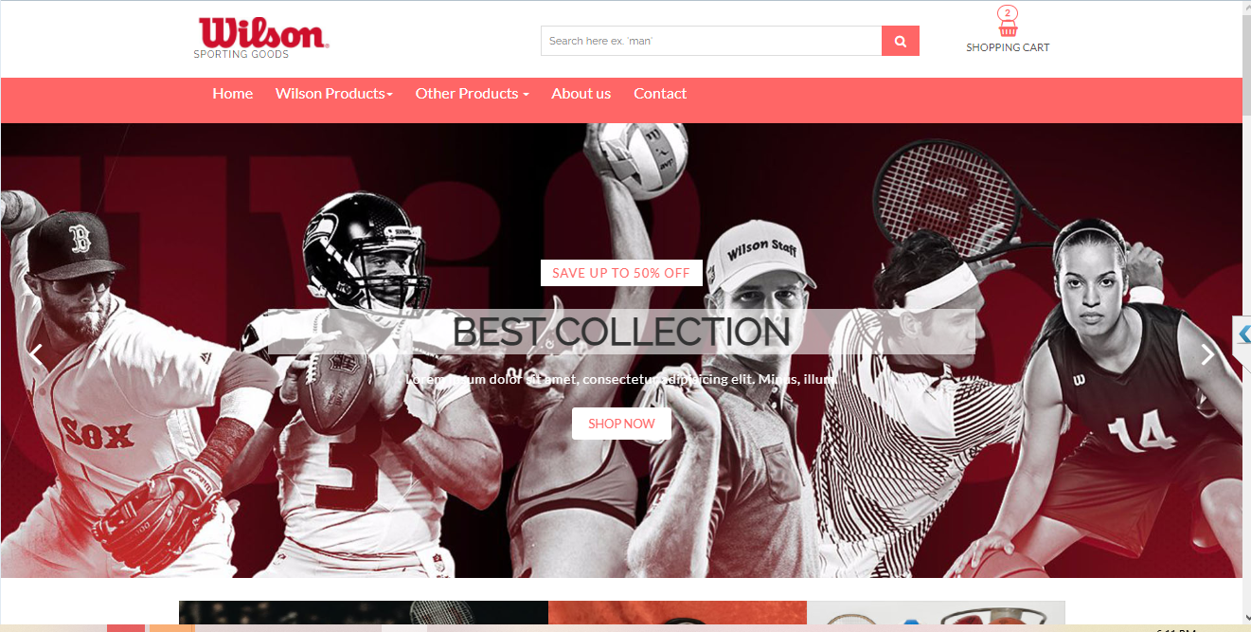

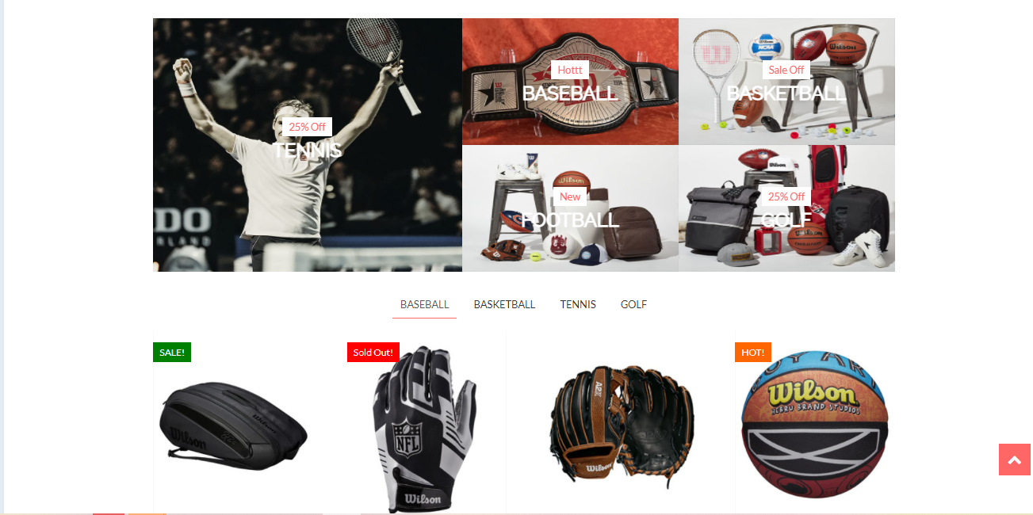

1. **Wilson Products**
2. Description

This shop page displays following information:

* All product that being sold at Wilson Sporting goods (football, basketball, tennis,golf) when click on 1 specific item, it will show the detail of that item
* Menu filter and search window to easily find items based on categories.

b)Screen shot

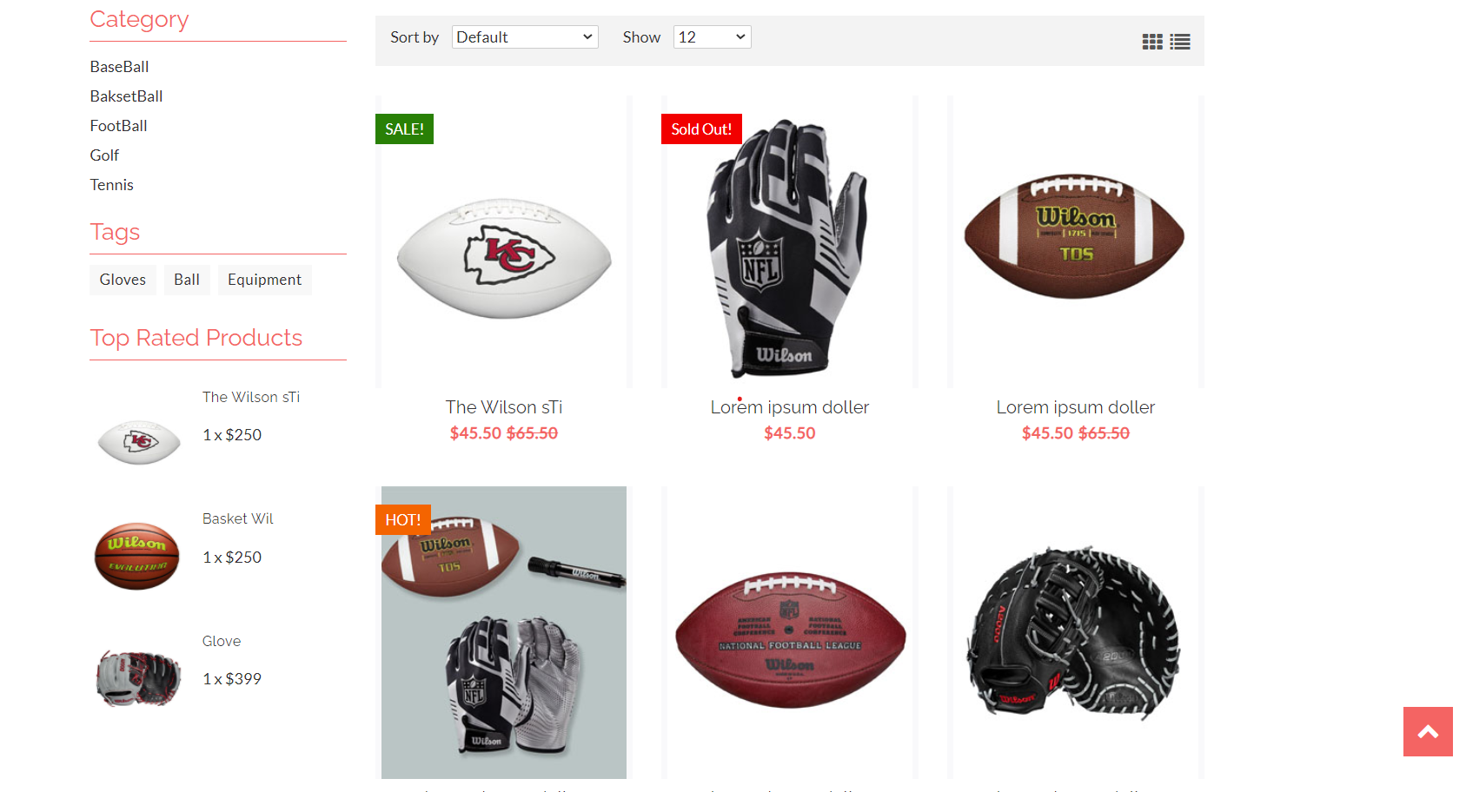



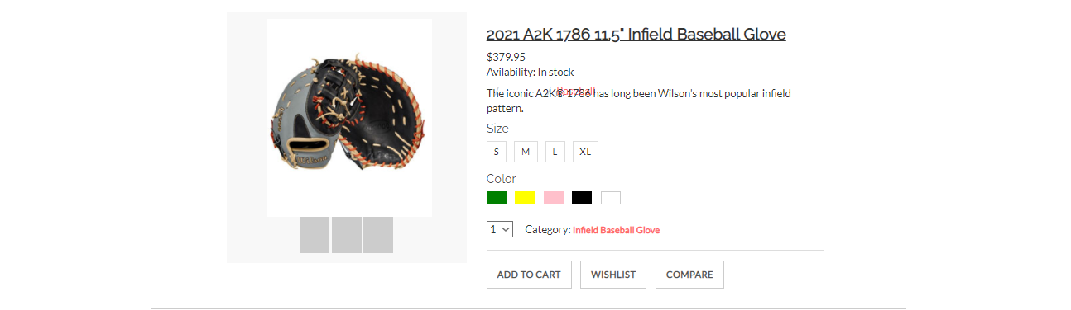

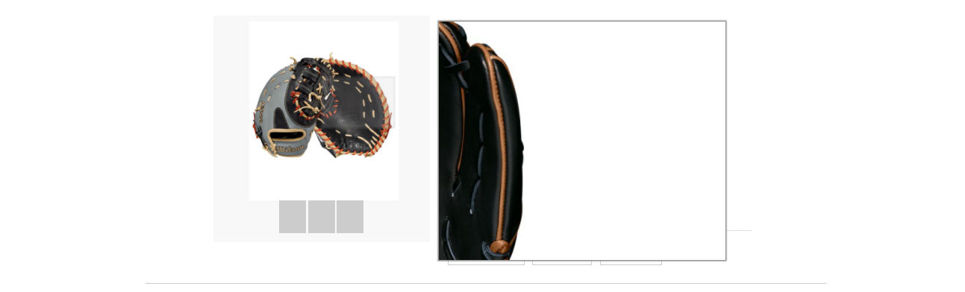

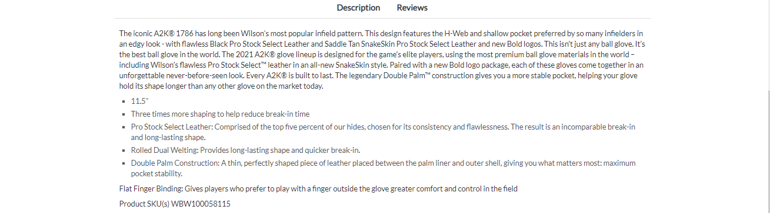

1. **About Us**
2. Description: This page displays information about the history of Wilson Sporting goods, our service that we provide and our team member
3. Screen shot

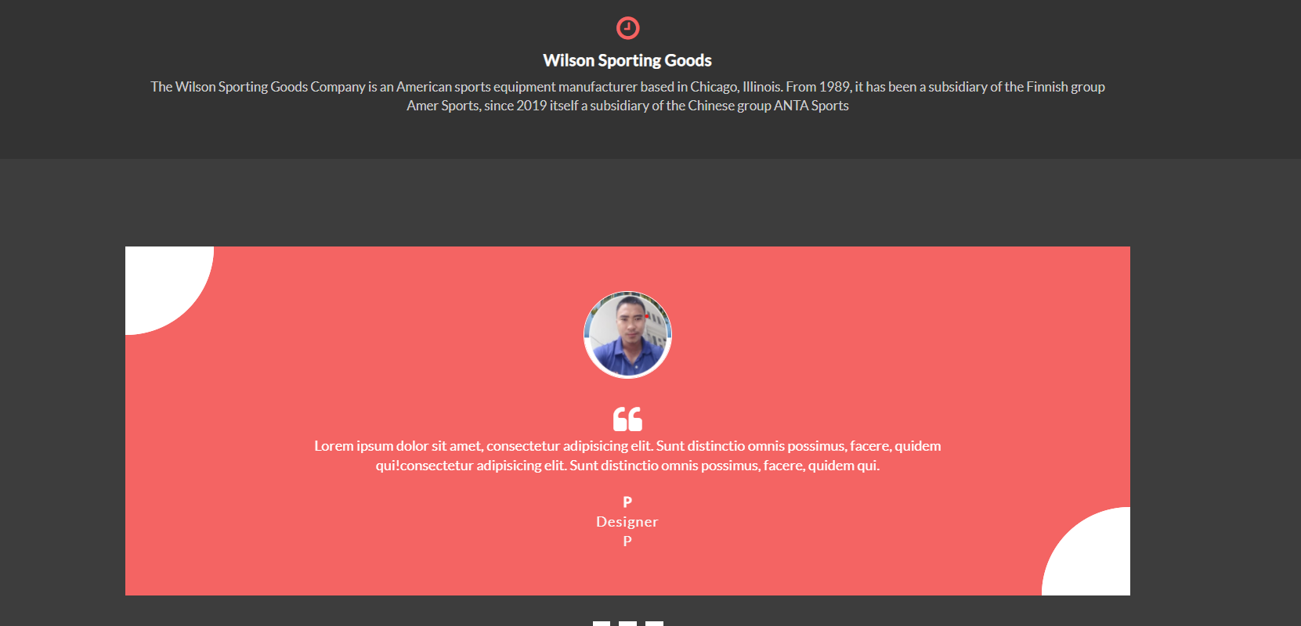

1. **Contact** **us**
2. Description

This page displays contact information: location, telephone number, email and a quick contact form for customer.

1. Screen shot

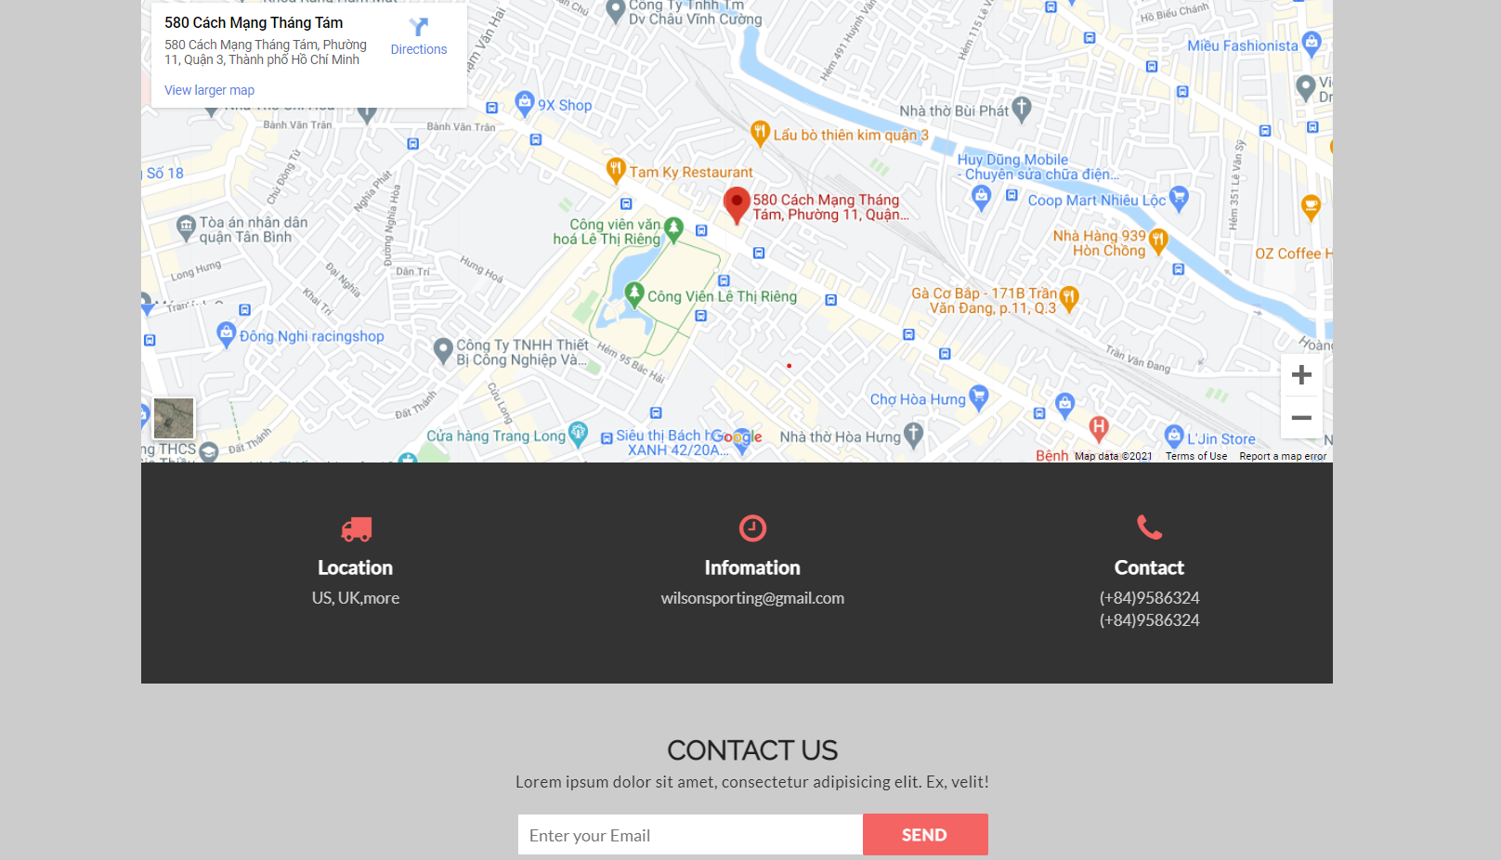

1. **Compare page**
2. Description

This page displays other products and compare them.

1. Screen shot

